Programs & Events Advisory Committee
August 19, 2020
On-Line Meeting

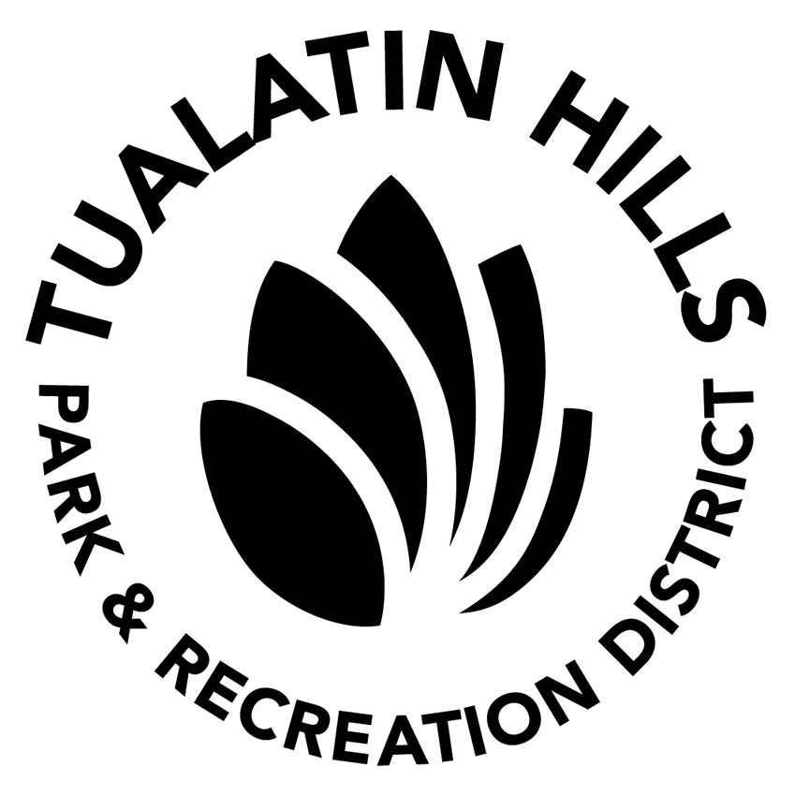

AGENDA

- Call Meeting to Order
- Welcome Members
- Introduce New Staff Liaison

- Approval of Minutes from February 2020

- Public Comment

- New Business

- Community Psyche Grant – Holly Thompson
- Recap of Community Events During Pandemic – Karin Madsen
- Physical Distancing & Health Safety Protocols – Karin Madsen
- Facility Reopening / Programming Update – Holly Thompson
- Marketing / Communications/ Registration Ideas – Committee Input

- Old Business
  - Review Outstanding Projects

- Wrap-up

- Adjourn
Public Notice: Due to the current State of Emergency as a result of the COVID-19 pandemic, the THPRD Program & Events Advisory Committee August 19, 2020 Regular Meeting will be conducted electronically.
Audience Time/ Public Testimony: Testimony is being accepted for this meeting by email only. If you wish to submit testimony, please do so by 4 pm on August 19, 2020. Email testimony to hthompson@thprd.org. Testimony received by the designated time will be read to the Committee during the applicable agenda item with a 3-minute time limit.
Public Attendance at the On-Line Meeting: The public is welcome to attend the meeting on-line. To attend, please email hthompson@thprd.org by 4 pm on August 19, 2020, to express your interest to attend. You will receive an email response with a link to join the meeting.

